Auto Ticket Classification using Flow Designer
Part 4 of 7 — Category & Subcategory DependencyPart 4 of 7 — Category & Subcategory Dependency

Activity 3: Implementing Dependency Between Category and Subcategory Choice Fields
The objective of this milestone is to implement a dependency relationship between the Category and Subcategory fields so that the available Subcategory options dynamically change based on the selected Category.
Navigation Steps:
- Open the Created Table Form and right-click on the Subcategory Field.
- Click on Configure Dictionary.
- Under Related links, click on Advanced view.
- Then select the Dependent Field section.
- Enable the checkbox Use dependent field = true.
- Then select the field Category as the Dependent on field.
- Then save the Form.
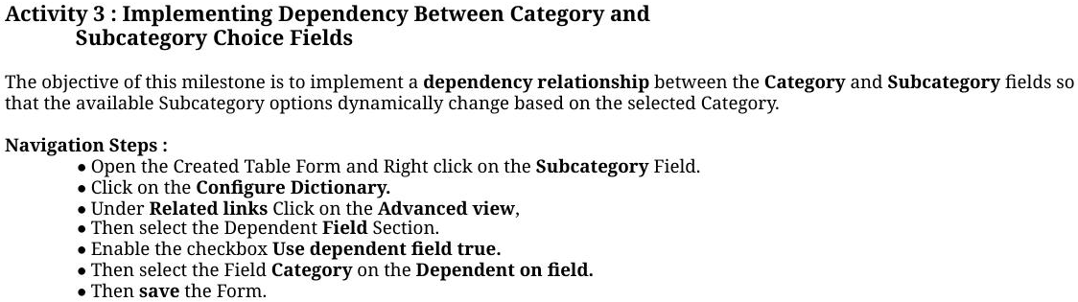
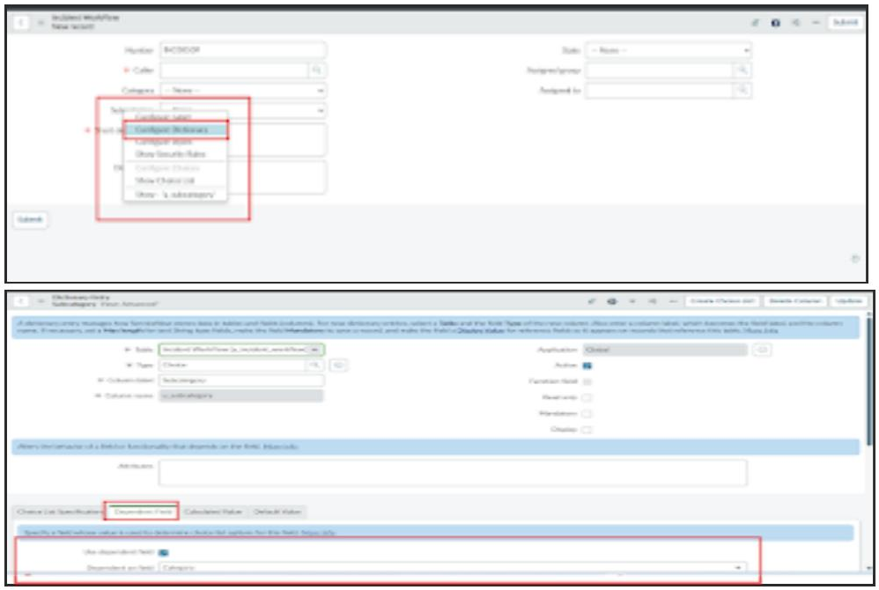
Now scroll down to the Choice section, then add the dependent fields so the option depends on the category (backend name mapped to subcategory choice values):
- Wi-Fi → Network
- Projector → Hardware
- Forgot password → Access
- Slow computer → Performance
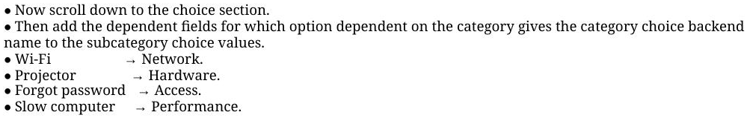
Then save the Form. It will now display each Subcategory choice separately, based on the Category selected.
